­­



Submitted to

:

Sir. Waqar Ahmed

***BS-Software Engineering 4th-E***

Title: Lab Reports

SDA

Hamza Mehmood

Roll# SP-21-110

NUML-S21-23530



National University of Modern Languages

# LAB 1

**Lab Title: Revision of UML concepts**

**Question 1:**

**Draw an appropriate UML diagram for the below given scenario. Also give reasoning of choosing diagram.**

A university consists of multiple faculties. Each faculty is led by a dean, who is an employee of the university. There are many faculties and no of faculties have been known each employee has a job id, name, phone no, and email address. Two categories research and administrative personnel are differentiated according to their duties in the university. Research associative are assigned to at least one institute, each institute has its well-known field of study, which includes project of certain no. of hours, title of project, starting and ending date. Some search associates called lecturers holds courses. All the courses have a unique name, id, no. of hours allocated to them.

**Answer:**

**Why do we need class diagram for given scenario?**

Class diagrams are the blueprints of system or subsystem. We can use class diagrams to model the objects that make up the system, to display the relationships between the objects, and to describe what those objects do and the services that they provide. Class diagrams are useful in many stages of system design.

As class diagram are used to model the static view of the system so, as seen in above scenario it can be better approach to use object-oriented concepts to relate the given information with the help of classes.

In the given scenario there is an employee class generalized with dean class which is child class and inherits some attributes of parent class There are two subclasses named as faculty of engineering and faculty of arts associated with dean class.

Both classes have unique attributes as given in scenario and these are private. Another class which includes some properties and two methods research and administrative personnel are mentioned is associated with one of the child classes of dean. Other classes named as course and project are associated with subclass named as categories with some properties mentioned above.

**Class Diagram:**

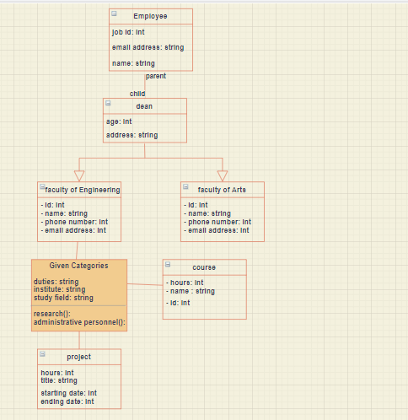

**Question 2:**

**Create a sequence diagram for following scenario of WhatsApp application**

* Creating a group on WhatsApp, sending the first message to the group, and checking status information of message sent.
* Sharing a picture and then a video from your gallery over your WhatsApp status and then checking who viewed your status.
* Creating and sending a new broadcast
* Do a video call to one of your WhatsApp contacts
* **Answer:**

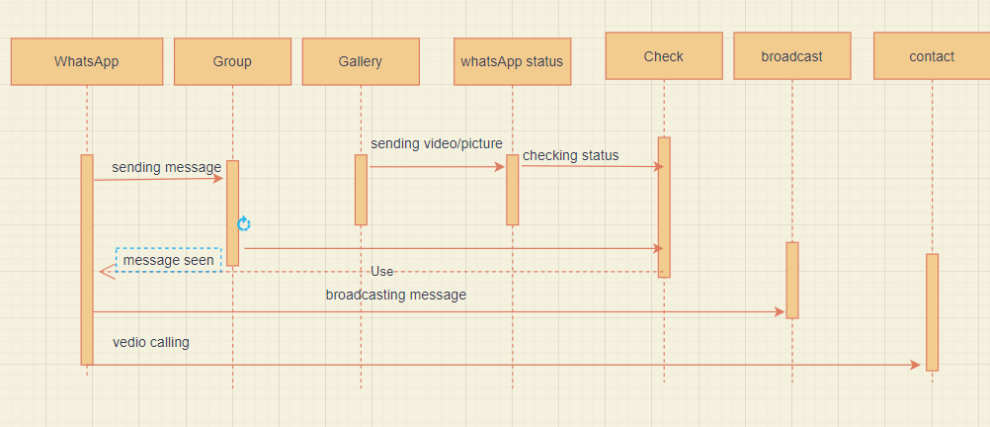

According given scenario, using sequence diagram at first the message is sent to WhatsApp group and then checked whether message has been reached or not.

Any picture or video is sharing from gallery to WhatsApp status and then checking who has seen it. Similarly, a message is broadcasted.

And doing a video call from WhatsApp to one of our contacts saved.

# LAB 2

**Consider following scenario**

At the beginning of each semester students may request a course catalogue from registrar containing a list of course offering for the semester. Information about each course, such as professor, department and prerequisites will be maintained by registrar to help students make informed decisions. The new on-line registration system will allow students to perform registration and select four course offerings for the coming semester. In addition, each student will indicate two alternative choices in case a course offering becomes filled or canceled. No course offering will have more than ten students. No course offering will have fewer than three students. A course offering with fewer than three students will be canceled. Once the registration process is completed for a student, the registration system sends information to the billing system, so the student can be billed for the semester. Professors must be able to access the on-line system to indicate which courses they will be teaching. Professors will also need to view course offering roster to see which students signed up for their course offering. For each semester, there is a period of time that students can change their schedules. Students must be able to access the on-line system during this time to add or drop courses. The billing system will credit all students for courses dropped during this period of time. The registrar would also maintain course curriculum and update it in the system

**Q1 Identify primary and secondary Actors of the system**.

**Primary Actors:**

* Student
* Professor
* Registrar

**Secondary Actors**:

* Registration System
* Billing System

**Q2 Create actor goal list for above scenario**

|  |  |
| --- | --- |
| **Actors** | **Goals** |
| Student | Requestcourse catalogue, select four courses, may change their schedule in specific period of time, can access online system to add and drop courses |
| Registrar | Maintain information about courses, professor and department, maintain and update course curriculum |
| Professor | Access online system to know which course they teach, view course offering roster |
| Registration system | Allow student to perform registration, send information |
| Billing System | Receive information, billed student for semester, credit all students for courses dropped |

**Q2 Identify Use Cases that appears as verbs.**

**Q3 Use Include and Extend relationship where needed**

**Q4 Draw a complete Use Case diagram of the system**

**Answer:**

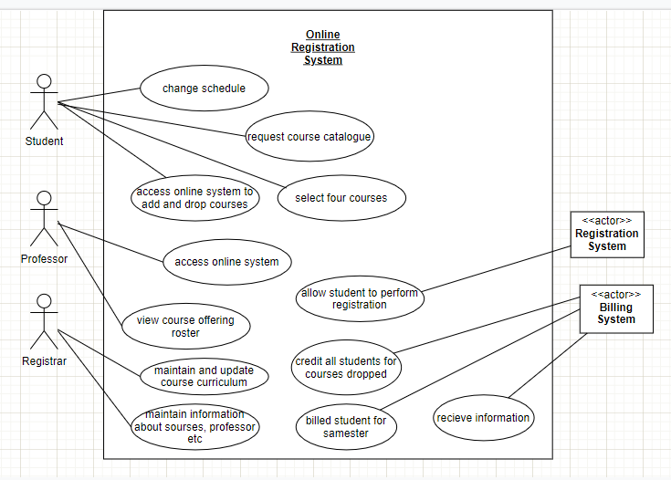

# LAB 3

**Q1**:

Consider an automated student registration system which requires student to login as well as provides registration to students. It also enables student to enroll in courses. The student can enroll in only those classes that are part of their degree fully dressed use case in two column formats for following use case **“Enroll in a course”**

**Answer:**

|  |  |
| --- | --- |
| **UC-01** | **Enroll in a course** |
| **Actor** | student |
| **Goal** | Student will get enrolled in courses which are related to degree |
| **Pre-requisite** | student must be login to system by providing necessary detail and should be registered one. |
|  | |  |  | | --- | --- | | User action   * Student search courses * Student select courses which are related to degree. * Student perform registration to get enrollment in selected courses | System response   * System shows various course list and allows student to search from list * System shows those courses which are selected by student * System register student and enroll student in selected courses. | |
| **alternate** | If student cannot find courses of interest, then he may ask to system about courses. |

# LAB 4

**Question 1:**

Draw a class diagram for a scenario of a test system. The process flow is outlined below. Use association according to your own understanding

**i. Students attend Classes;**

**ii. Teachers mark attendance;**

**iii. Teachers prepare test papers;**

**iv. Students write test papers;**

**v. Teachers check test papers;**

**vi. Teachers declare results;**

**Answer:**

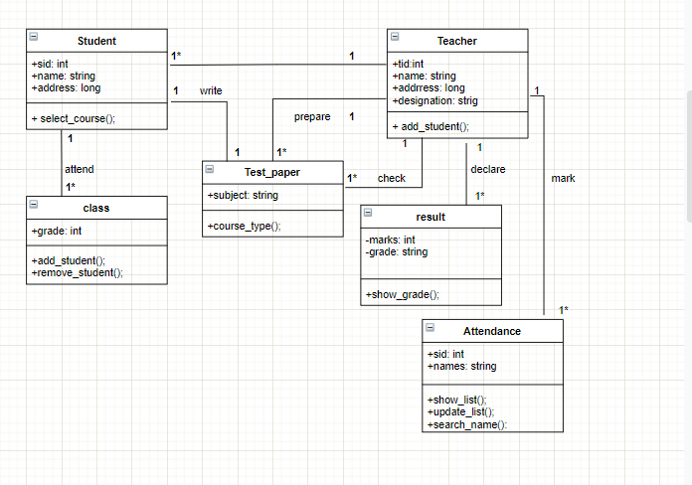

**Noun:**

* Student
* Name--- attribute of student
* Id—attribute of student
* Address--attribute of student
* Classes
* attendance
* Teacher
* Name-- attribute of teacher
* Id-- attribute of teacher
* Address-- attribute of teacher
* Designation-- attribute of teacher
* Teachers—redundant
* Test paper
* Test paper—redundant
* result

# LAB 5

**Q1. Draw an activity diagram with swim lanes for following scenario;**

The author submits a paper to an editor of a journal. The editor first checks whether the paper fit the theme of the journal. If not, the editor rejects the paper. Otherwise, the editor assigns the paper to several reviewers. The reviewers review the paper and write a review. The review is sent to the editor. The editor then assesses the quality of the paper with the help of reviewers' comments. If the quality is good, the paper will be accepted, and the author notified. Furthermore, the paper is forwarded to the publisher for publication. If the quality is bad, the editor rejects the paper.

**Diagram:**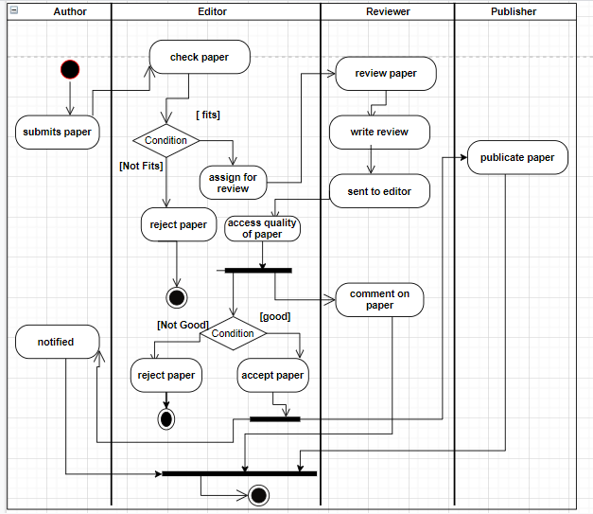

# LAB 6

**Question no. 1:**

Draw a sequence diagram with the following scenario statements

* + Firstly, the application is opened by the user.
  + The device then gets access to the web cam.
  + The webcam captures the image of the user.
  + The device uses algorithms to detect the face and predict the mood.
  + It then requests database for dictionary of possible moods.
  + The mood is retrieved from the database.
  + The mood is displayed to the user.
  + The music is requested from the database.
  + The playlist is generated and finally shown to the user.

**Diagram:**

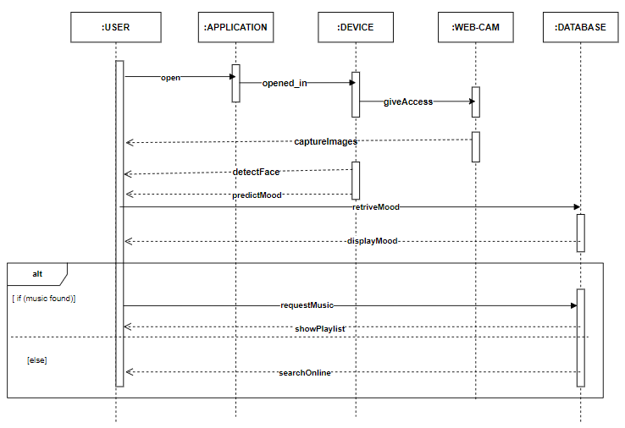

**Question no.2:**

Draw a sequence diagram for following scenario

* A student would like to book a laboratory session slot for his/her practical class. The scheduler will check for a free slot. If there is a free slot, the student will be accepted. The student will be assigned to a specific slot in the schedule. The student will be notified with a confirmation message. If there is no free slot available in the system, a message will be prepared by the scheduler and the notification will be sent to the student. The initial message login will be originated from the user interface and send to the scheduler.

**Diagram:**

